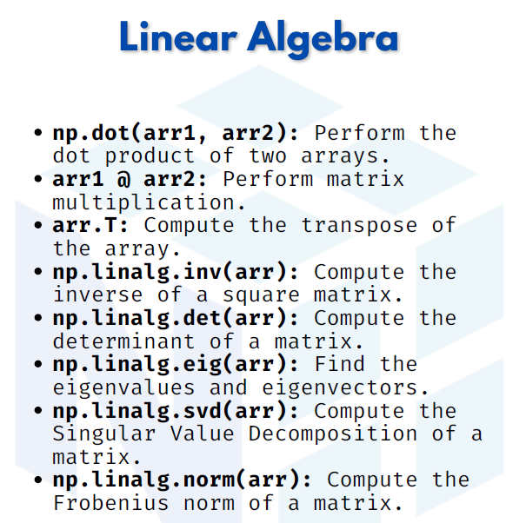

Linear ALGEBRA

1. np.dot(arr1, arr2) → Dot product of two arrays
The dot product multiplies arrays element-wise row × column.

import numpy as np
arr1 = np.array([1, 2])
arr2 = np.array([3, 4])
print(np.dot(arr1, arr2))

Output:
11

2. arr1 @ arr2 → Matrix multiplication
The @ operator is shorthand for matrix multiplication.

A = np.array([[1, 2], [3, 4]])
B = np.array([[5, 6], [7, 8]])
print(A @ B)
Output:
[[19 22]
[43 50]]

3. arr.T → Transpose of the array
The transpose swaps rows and columns.

A = np.array([[1, 2, 3],
[4, 5, 6]])
print(A.T)
Output:
[[1 4]
[2 5]
[3 6]]

4. np.linalg.inv(arr) → Inverse of a square matrix
The inverse matrix is the one that, when multiplied by the original, gives the identity matrix.

A = np.array([[1, 2],
[3, 4]])
print(np.linalg.inv(A))
Output:
[[-2. 1. ]
[ 1.5 -0.5]]

5. np.linalg.det(arr) → Determinant of a matrix
The determinant is a scalar value that tells us if a matrix is invertible.
print(np.linalg.det(A))
Output:
-2.0000000000000004

6. np.linalg.eig(arr) → Eigenvalues and Eigenvectors
Eigenvalues and eigenvectors are important in data science, PCA, and ML.
values, vectors = np.linalg.eig(A)
print("Eigenvalues:", values)
print("Eigenvectors:\n", vectors)

Output (example):
Eigenvalues: [-0.37228132 5.37228132]
Eigenvectors:
[[-0.82456484 -0.41597356]
[ 0.56576746 -0.90937671]]

7. np.linalg.svd(arr) → Singular Value Decomposition
SVD breaks a matrix into three matrices: U, Σ, Vᵀ. Widely used in ML & recommendation systems.
U, S, Vt = np.linalg.svd(A)
print("U:\n", U)
print("S:\n", S)
print("V^T:\n", Vt)
Output (example):
U:
[[-0.40455358 -0.9145143 ]
[-0.9145143 0.40455358]]
S:
[5.4649857 0.36596619]
V^T:
[[-0.57604844 -0.81741556]
[ 0.81741556 -0.57604844]]

8. np.linalg.norm(arr) → Frobenius norm of a matrix
The norm is a measure of vector/matrix magnitude. Frobenius norm = square root of sum of squares of all elements.

print(np.linalg.norm(A))
Output:
5.477225575051661

